Bit Plane Slicing:

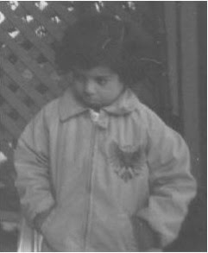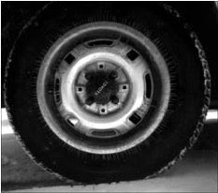

Fig1: Original Images





Code:

clc;

clear all;

close all;

g = rgb2gray(imread('tire_orig.jpg'));

[m,n] = size(g);

b = double(g);

c = de2bi(b);

c1 = c(:,1); %LSB

c2 = c(:,2);

c3 = c(:,3);

c4 = c(:,4);

c5 = c(:,5);

c6 = c(:,6);

c7 = c(:,7);

c8 = c(:,8); %MSB

r1 = reshape(c1,m,n);

r2 = reshape(c2,m,n);

r3 = reshape(c3,m,n);

r4 = reshape(c4,m,n);

r5 = reshape(c5,m,n);

r6 = reshape(c6,m,n);

r7 = reshape(c7,m,n);

r8 = reshape(c8,m,n);

figure(1);

subplot(241), imshow(r1), title('LSB layer');

subplot(242), imshow(r2), title('2nd layer');

subplot(243), imshow(r3), title('3rd layer');

subplot(244), imshow(r4), title('4th layer');

subplot(245), imshow(r5), title('5th layer');

subplot(246), imshow(r6), title('6th layer');

subplot(247), imshow(r7), title('7th layer');

subplot(248), imshow(r8), title('MSB layer');